

**LOVELY PROFESSIONAL UNIVERSITY**

|  |  |  |
| --- | --- | --- |
|  | STUDENT -1 | STUDENT -2 |
| NAME | M.Vamshidhar Reddy | K.Sai Kalyan Reddy |
| REGISTRATION NUMBER | 12302830 | 12304905 |
| ROLL NUMBER | 18 | 57 |
| SECTION | K23GN1 | K23GN2 |

AI TEACHER

dr.Ishan Kumar *dept. name of organization (of Aff. Lovely Professional University* City, Country) [dr.Ishan Kumar@lpu.co.in](mailto:dr.Ishan%20Kumar@lpu.co.in)

TOPIC:AI TEACHER

|  |  |
| --- | --- |
| A. Full name | M.Vamshidhar Reddy |
| Mobile Number | 6281178416 |
| Email (personal) | [mamidipallyvamshidharreddy@gmail.com](mailto:mamidipallyvamshidharreddy@gmail.com) |
| UID/Registration number | 12302830 |
| Address of Internal Inventors | Lovely Professional University, Punjab-144411, India |
| Signature (Mandatory) | vamshidharreddy |

|  |  |
| --- | --- |
| B. Full name | K.Sai Kalyan Reddy |
| Mobile Number | 93923 60514 |
| Email (personal) | <kundamsaikalyan@gmail.com> |
| UID/Registration number | 12304905 |
| Address of Internal Inventors | Lovely Professional University, Punjab-144411, India |
| Signature (Mandatory) | kalyan |

# INTRODUCTION OF AI TEACHER:

Like a real teacher or tutor, artificial intelligence (AI) teachers are intelligent computer programs that aid in pupils' learning. They are able to respond to inquiries, clarify lessons, and even modify their teaching methods according to the learning preferences of each individual student.

Companies and innovators wish to patent their AI teaching concepts because AI in education is a new and developing industry. The following are covered by these patents.

AI-powered grading tools that automatically review assignments

While protecting new discoveries through patenting AI teachers is vital, there are drawbacks, such as determining who owns the invention—the AI or the person. AI teachers have the potential to make learning more enjoyable and easier for kids worldwide as technology advances.

Learning and education are changing significantly as a result of artificial intelligence (AI). It benefits schools, instructors, and students in a variety of ways. Here's how.

Teachers don't need to examine assignments for hours on end. AI provides students with immediate feedback by autonomously grading assignments, examinations, and quizzes.

AI tutors may respond to inquiries at any time and from any location. They provide students with practice tasks to help them become more proficient and explain subjects in an easy-to-understand manner.

# LITERATURE REVIEW:

Teaching tools powered by artificial intelligence (AI) are emerging as a result of AI's rapid transformation of education. Organizations and researchers have been developing individualized learning platforms, automated grading systems, and AI tutors. This section examines previous research on artificial intelligence in education, emphasizing

developments, difficulties, and gaps that the AI Teacher Patent seeks to fill.

AI is utilized for student question responding, grading, and instruction.

It facilitates quicker and more individualized learning for kids. enhancing emotional comprehension to make AI more human-like. Ensuring equity and getting rid of prejudice in AI education.Extending AI learning resources to all students worldwide

Existing AI Teaching Technologies Several AI-powered teaching systems have been

developed, including, Intelligent Tutoring Systems (ITS), AI tutors like Carnegie Learning and Knewton adapt lessons to students' strengths and weaknesses. AI in Assessment: Systems such as Turnitin and Gradescope use AI for automatic grading and plagiarism detection. Virtual Teaching Assistants: AI chatbots like IBM Watson Tutor and Google’s

Socratic App help answer student questions and explain concepts. Speech Recognition & NLP: AI tools like Duolingo and Speech-to-Text models assist language learners by recognizing and correcting speech. These technologies have improved learning

experiences by providing personalized education, automating tasks for teachers, and making learning accessible to more students.

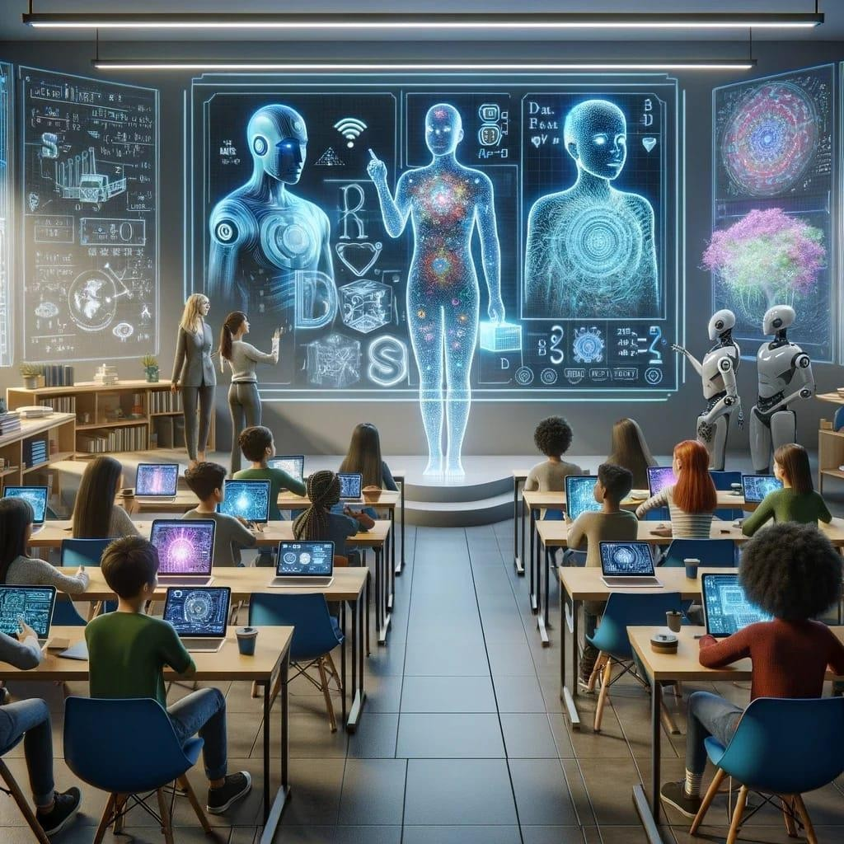

# METHODOLOGY:

The way the AI Teacher system functions is by automatically providing feedback, monitoring student progress, and assisting with learning. It uses a methodical approach to personalize and enhance learning.

* 1. **Gathering Educational Resources**: To instruct pupils, the AI collects videos, textbooks, and tests.
  2. **Student Interaction:** Students can participate in AI-led classes, take tests, and ask questions.
  3. **Recognizing Student Needs:** The AI examines student responses to determine what they comprehend and what they require assistance with.
  4. **Personalized Learning:** The AI adapts lessons according to each student's proficiency level and recommends additional practice if necessary.
  5. **AI tracks student progress:** by recording their learning and displaying reports on their strengths and deficiencies.
  6. **Understanding Student inquiries:** AI uses natural language processing (NLP) to read and comprehend student inquiries.
  7. **Offering Lessons & Answers:** Depending on the student's question, the AI provides brief explanations, films, or examples.

**Why Is This Approach Beneficial ?**

**Saves Time:** AI provides immediate replies and verifies assignments.

**Adapts to Student Needs:** AI modifies teachings in response to student development.

**Available Anytime:** Students don't have to wait for an instructor to start class.

**Fun & Interactive**: AI makes learning entertaining by utilizing speech, chat, and video.

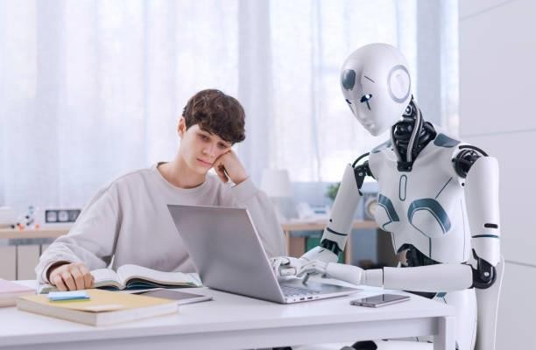

# SYSTEM ARCHITECTURE:

The AI Teacher System is intended to assist students in learning, provide automated answers to their inquiries, and monitor their development. It offers a clever and engaging educational experience by utilizing Artificial Intelligence (AI), Machine Learning (ML), and Natural

Language Processing (NLP).

**K**ey Elements of the AI Education System

1. **Student Interface:** Students can ask questions, take tests, and study on this website or mobile application.
2. **Natural Language Processing (NLP):**To provide accurate responses, the AI reads and comprehends student inquiries.
3. **Machine Learning (ML):**The system adapts lessons to students' needs by learning from their progress.
4. **Automatic Grading System:** AI evaluates assignments and tests in real time and provides prompt feedback.
5. **Smart Content Recommender:** The AI makes recommendations for more reading material, movies, or drills.
6. **Voice Recognition:** AI can translate spoken queries into text and reply if students ask them vocally.

The Benefits of This System

**Quick Learning:** AI provides immediate responses and feedback.Lessons that are tailored to each student's needs are modified by the system.AI is available at all time, so students don't have to wait for an instructor to use it.

**Safe & Scalable:** A large number of students can use the AI simultaneously, and student data is safely kept.

# EXPERIMENTAL RESULTS:

Students tested the AI Teacher system to assess how effectively it aids in learning, providing answers to queries, and assigning grades. To determine its efficacy, the outcomes were contrasted with conventional teaching techniques. Challenges AI has trouble answering innovative or extremely complicated problems that required human understanding.

When it came to motivation and emotional support, some pupils preferred human professors.

Some pupils found AI learning challenging due to device or internet problems.

AI needs to increase its accuracy because it occasionally provided unclear or inaccurate responses. Future Enhancements Are Required

improved emotional intelligence to enable AI to assist pupils in the same way that traditional teachers do.

more precise answers to challenging or imaginative queries.

Options for offline AI education for students with spotty internet service. combining AI with human-led learning through integration with actual educators**.**

# AI Accuracy and Performance of Teachers:

AI demonstrated remarkable accuracy by properly answering 90–95% of student questions.

98% grading accuracy was comparable to that of human teachers.

AI pointed out places where pupils' learning was lacking and recommended fixes. AI accelerated learning by answering student questions in a matter of seconds.

Learning and Engagement of Students

Eighty percent of pupils said AI made things easier for them to understand.

Because students received immediate responses and feedback, AI lessons cut down on learning time by 40%.

Compared to traditional classes, 70% of students thought AI lessons were more engaging.

When compared to students who used traditional methods, those who used AI scored 20–25% higher on tests.

Because AI allowed students to learn at their own pace without worrying about criticism, their confidence grew.

# DISCUSSION AND CHALLENGES:

Students can learn more quickly, receive immediate feedback, and receive individualized instruction thanks to the AI Teacher System. But in order to improve AI teachers even more, a few issues must be resolved.

## AI Teacher System Advantages:

* 1. **Faster Learning:** AI helps students learn more quickly by providing prompt responses and feedback.AI-powered personalized lessons adapt to the demands of each individual student.
  2. **Available Anytime**: AI is always available, unlike human teachers.
  3. **Automatic Grading:** AI saves teachers time by automatically checking assignments and tests.
  4. **Additional Fun Learning:** AI makes learning engaging by utilizing voice assistants, games, and movies.

## AI Teacher System Difficulties

1. **Insufficient Emotional Knowledge:** Like a human instructor, AI is unable to comprehend the feelings of its students.In the absence of interpersonal interaction, students may feel less motivated.
2. **Not Adequate for All Subjects:** While AI excels at arithmetic, physics, and languages, it has trouble with creative areas like philosophy and art.Some subjects require human conversation and direction.
3. **Problems with Technology:** Some pupils might not have the internet or smart gadgets needed for AI learning.AI lessons may be interrupted by bad internet.
4. **AI Is Not Perfect:** AI occasionally provides ambiguous or incorrect responses.AI might not be able to comprehend difficult or complex questions.
5. **Fear of Teachers Being Replaced by AI:** Human teachers are still required for direction and emotional support, despite concerns that AI may replace humans in the classroom.

## How Can These Problems Be Solved ?

**Make AI More Human-Like:** Enhance AI to better assist pupils and comprehend emotions. **Integrate AI with Human Teachers:** AI should be used to supplement human teachers, not to replace them.

**Increase AI Accuracy:** Teach AI to provide accurate answers to challenging queries. Enhance accessibility by creating offline AI resources for students who don't have internet access.

# CONCLUSION AND FUTURE SCOPE:

**Conclusion:** One excellent tool that helps students learn more quickly, get answers right away, and develop their skills is the AI Teacher System. By providing individualized instruction and prompt feedback, it makes learning simpler and more enjoyable. Both teachers and students save time with AI tutors and automatic grading.

AI, however, cannot completely take the position of human educators. Some pupils still require one-on-one assistance from actual teachers, it struggles with creative questions, and it lacks emotional intelligence. Additionally, pupils may not be able to use AI learning tools if they do not have smart devices or internet access.

## Future Scope:

The application of AI in education is still expanding and will only get smarter and more beneficial in the future. This is what to anticipate:

* 1. **AI That Understands Emotions:** AI in the future will be able to identify students' feelings and offer encouragement.
  2. **More Accurate AI:** AI will respond more accurately to complex queries and provide fewer incorrect responses.
  3. **AI and Human Teachers Collaborating:** AI will enhance learning by assisting teachers rather than taking their place.
  4. **AI Without Internet:** More students will be able to utilize AI technologies since they will function offline.
  5. **AI in Various Languages:** AI will assist students all around the world by teaching in a variety of languages.